________________________

REQUEST FOR PROPOSAL (RFP)
________________________
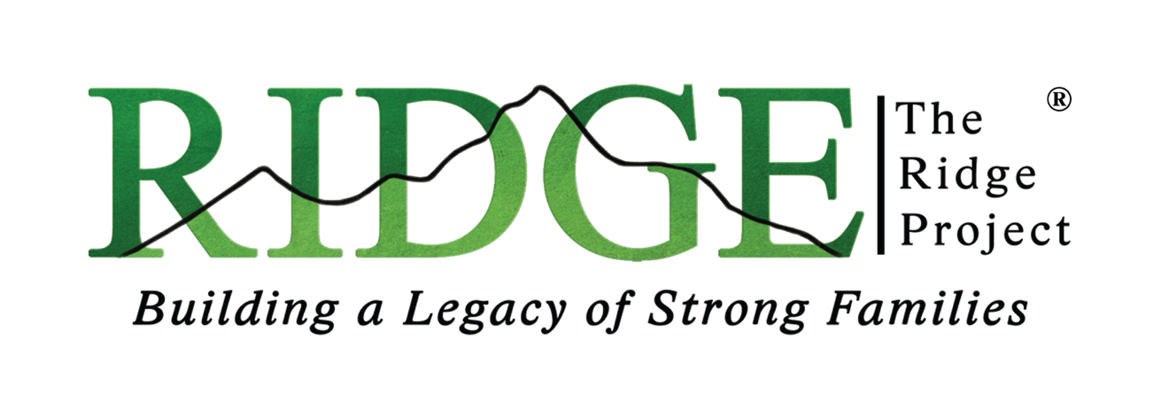

Career and Employment Program
REQUEST FOR BID
#17505-CEP-221

Prepared By: Catherine Tijerina, Co-Executive Director, The RIDGE Project
Date: October 3, 2022

SUBMISSION DEADLINE: October 15, 2022
QUESTION SUBMISSION DEADLINE: October 12, 2022

Questions may be submitted in written form no later than October 12, 2022, to:

RFP Contact Name: | Charles VanRenterghem
Contact Address: | Project Director  J169 State Route 65  McClure, OH 43534
Email Address: | Chuck.VanRenterghem@theridgeproject.com

INTRODUCTION
The RIDGE Projects, Inc. invites and welcomes proposals to support their Career and Employment project. Please take the time to carefully read and become familiar with the proposal requirements. All proposals submitted for consideration must be received by the time as specified above under the "SUBMISSION DEADLINE."

BIDDERS MUST PERFORM THE WORK DIRECTLY AND NOT CONTRACT OUT – NO EXCEPTIONS.

PROJECT OBJECTIVE
The objective and goal for this project is to provide fulfillment services for a character-based, workforce development package to include curriculum, curriculum training, data management and tracking, and programmatic materials and supplies.

PROJECT SCOPE AND SPECIFICATIONS

As the data management and curriculum fulfillment company for the Career and Employment Program, the winning bid will provide over the course of a 39-month period (with a possible extension up to five years dependent upon funding and contract performance):

- A Case Management Systems hosting site to accommodate the needs of this project for engagement, accountability, and case management.

- Maintain a digital case management and application tracking system and provide custom development so that it can be used for this project.

- Must be able to generate and customize reports for this project.

- Provide an evidence-based, reentry approved, cognitive behavioral curriculum for up to 400 clients that develops emotional intelligence, resiliency, self-regulation, perseverance, and hopefulness* that prepares prisoners to be successful in workforce, family, and community.
- The curriculum must also be compatible (and available immediately upon contract award) with digital platforms (including institutional tablets and platforms) both inside and outside of the Ohio Department of Corrections (ODRC). The curriculum must be compatible and deliverable through web-based systems and prison-based tablets as live stream and on-demand that can be accessed both inside and outside of ODRC.

- Must have documented experience providing effective curriculum to the incarcerated population. (Documented outcomes including reduced recidivism)

- Provide onsite curriculum training for staff on the curriculum, ondemand services, and case management system.

- Provide up to 10 hours monthly of ongoing technical support for the curriculum TA and Case Management System, (reporting, etc.)

- Provide curriculum themed t-shirts, bracelets, and lapel pins, for all completers.

- Provide curriculum themed attire for staff, including hoodies, t-shirts, lapel pins, bracelets, and hats.

*Curriculum must include already developed pre and post surveys to measure the outcomes of the program, as well as a proven track record of reducing recidivism.

DEADLINE TO SUBMIT PROPOSAL
All proposals must be received by no later than 11:59 P.M. Eastern Time, on October 15, 2022, for consideration in the project proposal selection process.

PROPOSAL SELECTION CRITERIA
Only those proposals received by the stated deadline will be considered. All proposals, submitted by the deadline, will be reviewed, and evaluated based upon information provided in the submitted proposal. In addition, consideration will be given to cost and performance projections. Furthermore, the following criteria will be given considerable weight in the proposal selection process:

- Proposals received by the stipulated deadline must be in the correct format.
- Bidder's alleged performance effectiveness of their proposal's solution regarding the Project Objective of reducing recidivism.
- Bidder's performance history and alleged ability to timely deliver proposed services.
- Bidder's ability to provide proof of effectiveness (reducing recidivism and delivering digital, on-demand virtual or face-to-face programming).
- Bidder’s responsiveness to the needs of the Case Management System as detailed above.
- Overall cost effectiveness of the proposal.

The RIDGE Project, Inc. shall reserve the right to cancel, suspend, and/or discontinue any proposal at any time they deem necessary or fit without obligation or notice to the proposing bidder/contractor.

PROPOSAL SUBMISSION FORMAT
The following is a list of information that the Bidder should include in their proposal submission:

Summary of Bidder Background
- Bidder's Name(s)
- Bidder's Address
- Bidder's Contact Information (and preferred method of communication)
- Legal Form of Bidder (e.g. sole proprietor, partnership, corporation)
- Date Bidder's Company Formed
- Description of Bidder's company in terms of size, range and types of services offered and clientele.
- Bidder's principal officers (e.g. President, Chairman, Vice President(s), Secretary, Chief Operating Officer, Chief Financial Officer, General Managers) and length of time each officer has performed in his/her field of expertise.
- Bidder's Federal Employee Identification Number (FEIN)
- Evidence of legal authority to conduct business in Ohio. (e.g. business
license number).
- Evidence of established track record for providing services and/or deliverables that are the subject of this proposal (attachments required).

Cost Proposal Summary and Breakdown
- Include a detailed list of curriculum costs. (participant books, facilitator manuals)
- A detailed list of cost of hoodies, t-shirts, hats, pins, bracelets, and certificates.
- A detailed list of cost of training facilitators.
- A detailed cost breakdown of the cost of digital deployment for ondemand.
- A monthly cost for the 10 hours of generating and customizing reports/data management, data, and case management tracking system.
- A detailed list of any and all expected costs or expenses related to the
proposed project.
- Summary and explanation of any other contributing expenses to the total cost.
- Include in Excel spreadsheet format ONLY with supporting narrative as needed

